Qur’an chapter | R | M | T
1. Al-Fatihah (the Opening)
2. Al-Baqarah (the Cow)
3. Aali Imran (the Family of Imran) |  |  | 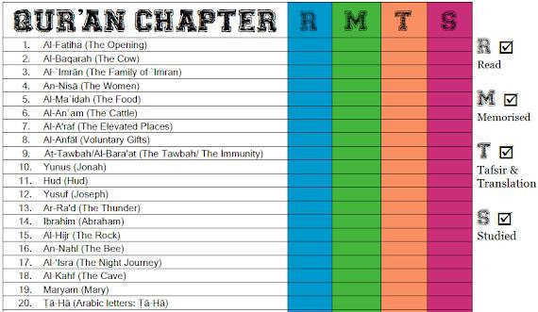
4. An-Nisa’ (the Women)
5. Al-Ma’idah (the Table)
6. Al-An’am (the Cattle)
7. Al-A’raf (the Heights)
8. Al-Anfal (the Spoils of War)
9. At-Taubah (the Repentance)
10. Yunus (Yunus)
11. Hud (Hud)
12. Yusuf (Yusuf)
13. Ar-Ra’d (the Thunder)
14. Ibrahim (Ibrahim)
15. Al-Hijr (the Rocky Tract)
16. An-Nahl (the Bees)
17. Al-Isra’ (the Night Journey)
Qur’an chapter | R | M | T
18. Al-Kahf (the Cave)
19. Maryam (Maryam)
20. Ta-Ha (Ta-Ha)
21. Al-Anbiya’ (the Prophets)
22. Al-Haj (the Pilgrimage)
23. Al-Mu’minun (the Believers)
24. An-Nur (the Light)
25. Al-Furqan (the Criterion)
26. Ash-Shu’ara’ (the Poets)
27. An-Naml (the Ants)
28. Al-Qasas (the Stories)
29. Al-Ankabut (the Spider)
30. Ar-Rum (the Romans)
31. Luqman (Luqman)
32. As-Sajdah (the Prostration)
33. Al-Ahzab (the Combined Forces)
34. Saba’ (the Sabeans)
Qur’an chapter | R | M | T
35. Al-Fatir (the Originator)
36. Ya-Sin (Ya-Sin)
37. As-Saffah (Those Ranges in Ranks)
38. Sad (Sad)
39. Az-Zumar (the Groups)
40. Ghafar (the Forgiver)
41. Fusilat (Distinguished)
42. Ash-Shura (the Consultation)
43. Az-Zukhruf (the Gold)
44. Ad-Dukhan (the Smoke)
45. Al-Jathiyah (the Kneeling)
46. Al-Ahqaf (the Valley)
47. Muhammad (Muhammad)
48. Al-Fat’h (the Victory)
49. Al-Hujurat (the Dwellings)
50. Qaf (Qaf)
51. Adz-Dzariyah (the Scatterers)
Qur’an chapter | R | M | T
52. At-Tur (the Mount)
53. An-Najm (the Star)
54. Al-Qamar (the Moon)
55. Ar-Rahman (the Most Gracious)
56. Al-Waqi’ah (the Event)
57. Al-Hadid (the Iron)
58. Al-Mujadilah (the Reasoning)
59. Al-Hashr (the Gathering)
60. Al-Mumtahanah (the Tested)
61. As-Saf (the Row)
62. Al-Jum’ah (Friday)
63. Al-Munafiqun (the Hypocrites)
64. At-Taghabun (the Loss & Gain)
65. At-Talaq (the Divorce)
66. At-Tahrim (the Prohibition)
67. Al-Mulk – (the Kingdom)
68. Al-Qalam (the Pen)
Qur’an chapter | R | M | T
69. Al-Haqqah (the Inevitable)
70. Al-Ma’arij (the Elevated Passages)
71. Nuh (Nuh)
72. Al-Jinn (the Jinn)
73. Al-Muzammil (the Wrapped)
74. Al-Mudaththir (the Cloaked)
75. Al-Qiyamah (the Resurrection)
76. Al-Insan (the Human)
77. Al-Mursalat (Those Sent Forth)
78. An-Naba’ (the Great News)
79. An-Nazi’at (Those Who Pull Out)
80. ‘Abasa (He Frowned)
81. At-Takwir (the Overthrowing)
82. Al-Infitar (the Cleaving)
83. Al-Mutaffifin (Those Who Deal in Fraud)
84. Al-Inshiqaq (the Splitting Asunder)
85. Al-Buruj (the Stars)
Qur’an chapter | R | M | T
86. At-Tariq (the Nightcomer)
87. Al-A’la (the Most High)
88. Al-Ghashiyah (the Overwhelming)
89. Al-Fajr (the Dawn)
90. Al-Balad (the City)
91. Ash-Shams (the Sun)
92. Al-Layl (the Night)
93. Adh-Dhuha (the Forenoon)
94. Al-Inshirah (the Opening Forth)
95. At-Tin (the Fig)
96. Al-‘Alaq (the Clot)
97. Al-Qadar (the Night of Decree)
98. Al-Bayinah (the Proof)
99. Az-Zalzalah (the Earthquake)
100. Al-‘Adiyah (the Runners)
101. Al-Qari’ah (the Striking Hour)
102. At-Takathur (the Piling Up)
Qur’an chapter | R | M | T
103. Al-‘Asr (the Time)
104. Al-Humazah (the Slanderer)
105. Al-Fil (the Elephant)
106. Quraish (Quraish)
107. Al-Ma’un (the Assistance)
108. Al-Kauthar (the River of Abundance)
109. Al-Kafirun (the Disbelievers)
110. An-Nasr (the Help)
111. Al-Masad (the Palm Fiber)
112. Al-Ikhlas (the Sincerity)
113. Al-Falaq (the Daybreak)
114. An-Nas (Mankind)

